Setup guide

Preparing
Copy folder Database, Source, Website to Hard disk.

Setup database (tao account admin)
- Run sql server management with administration permission
- Create login user
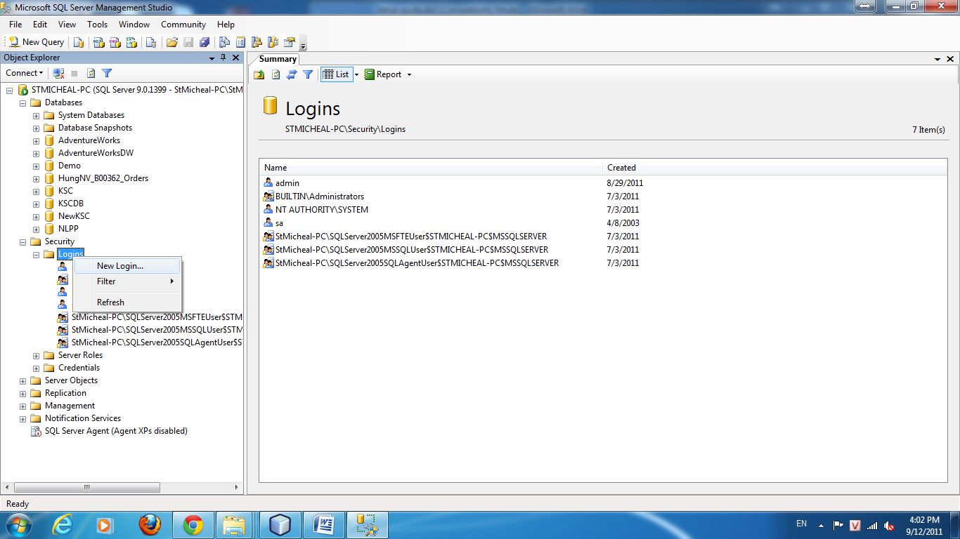
Figure 1. Create login user
Username: admin
Password: admin
Role: sysadmin
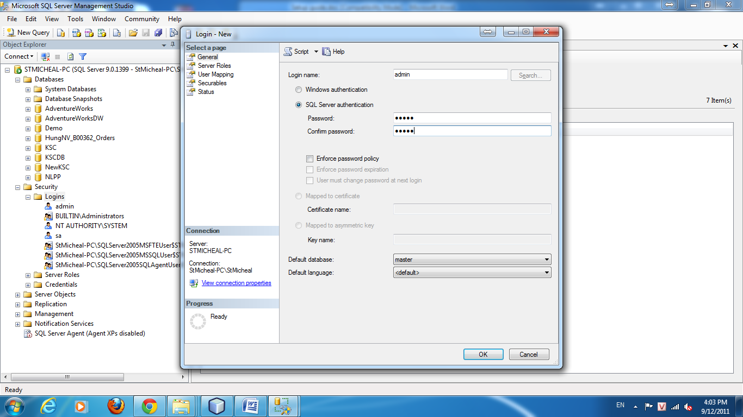
Figure 2. New user, name: admin, password: admin
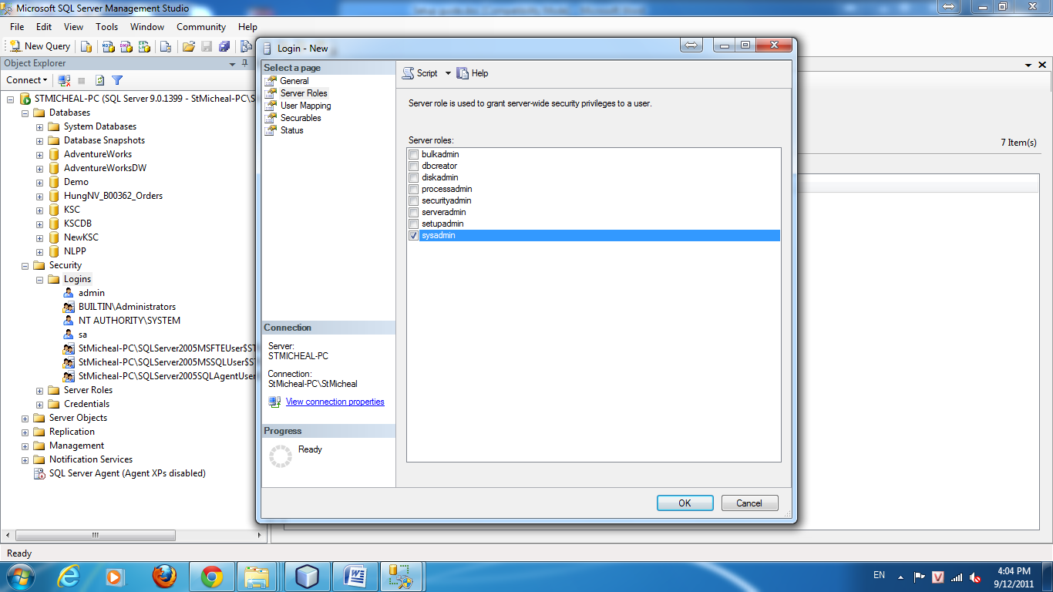
Figure 3. Set role: sysadmin
- Disconnect to database engine and reconect user admin

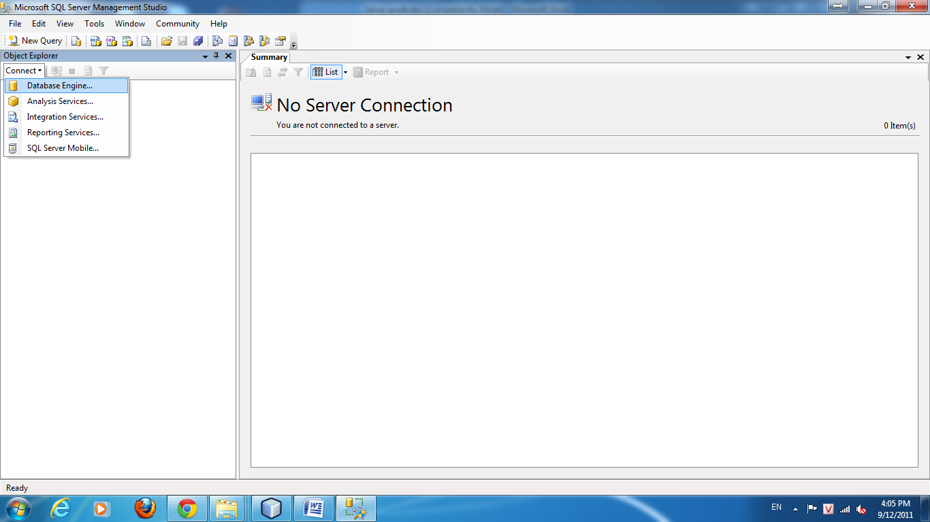
Figure 4. Connect database engine
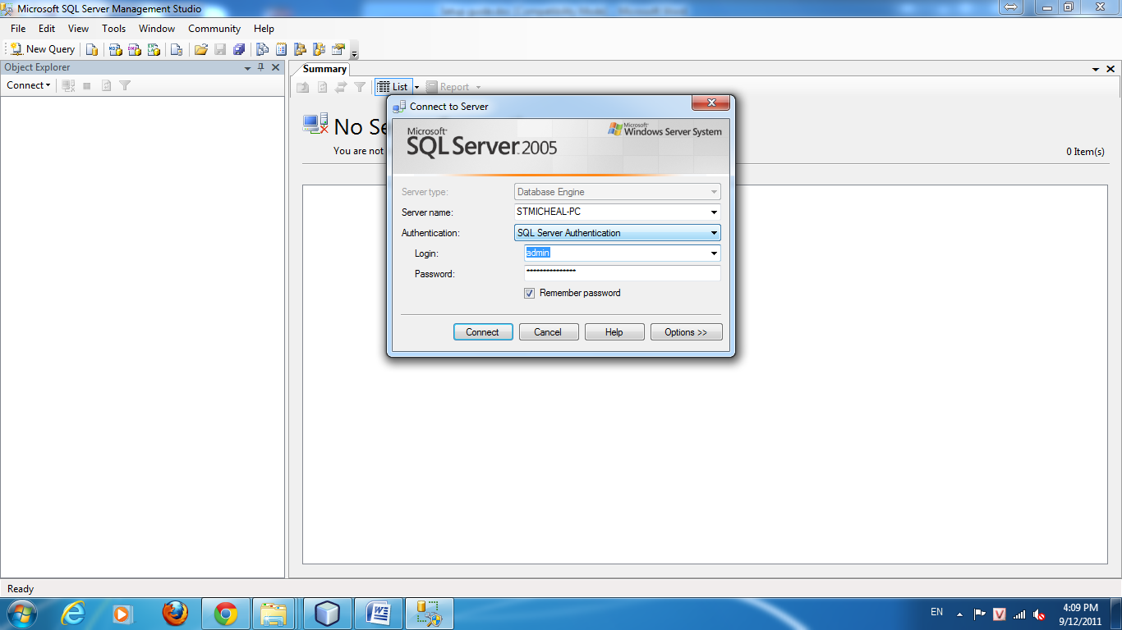
Figure 5. choose login user: admin

- Attach database file: Database\NLPP.mdf. If you can’t attach this database file, you can execute file: Database\NLPP.sql.
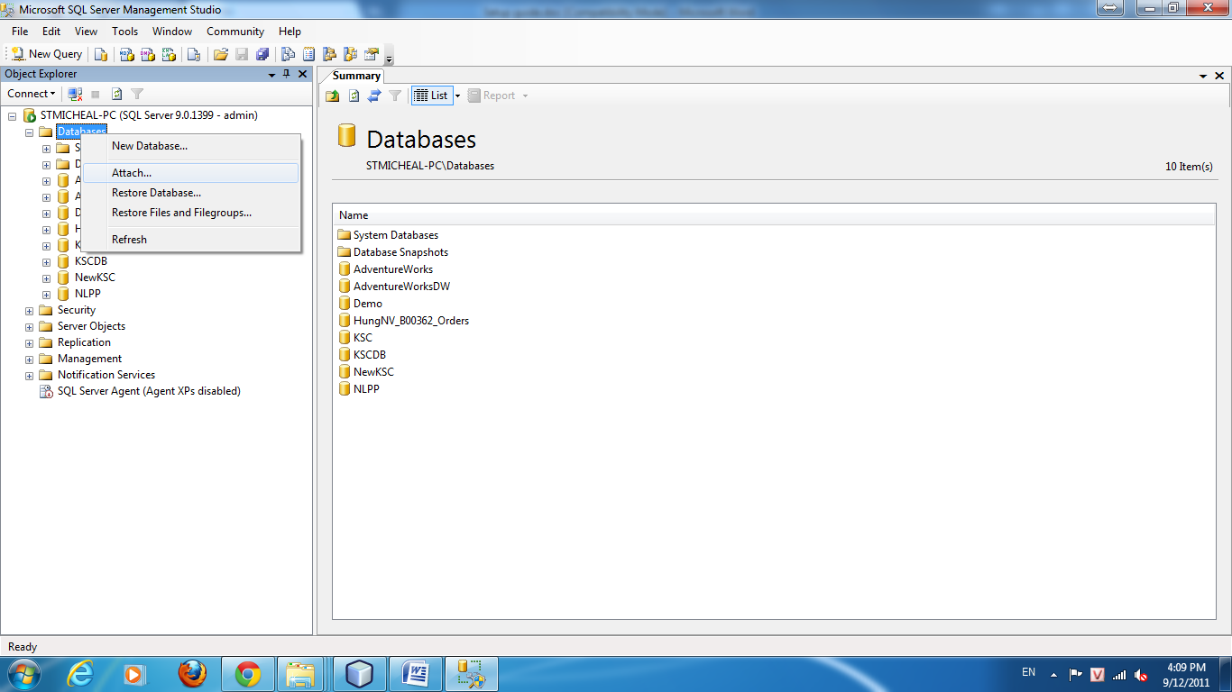
Figure 6. Choose attach function
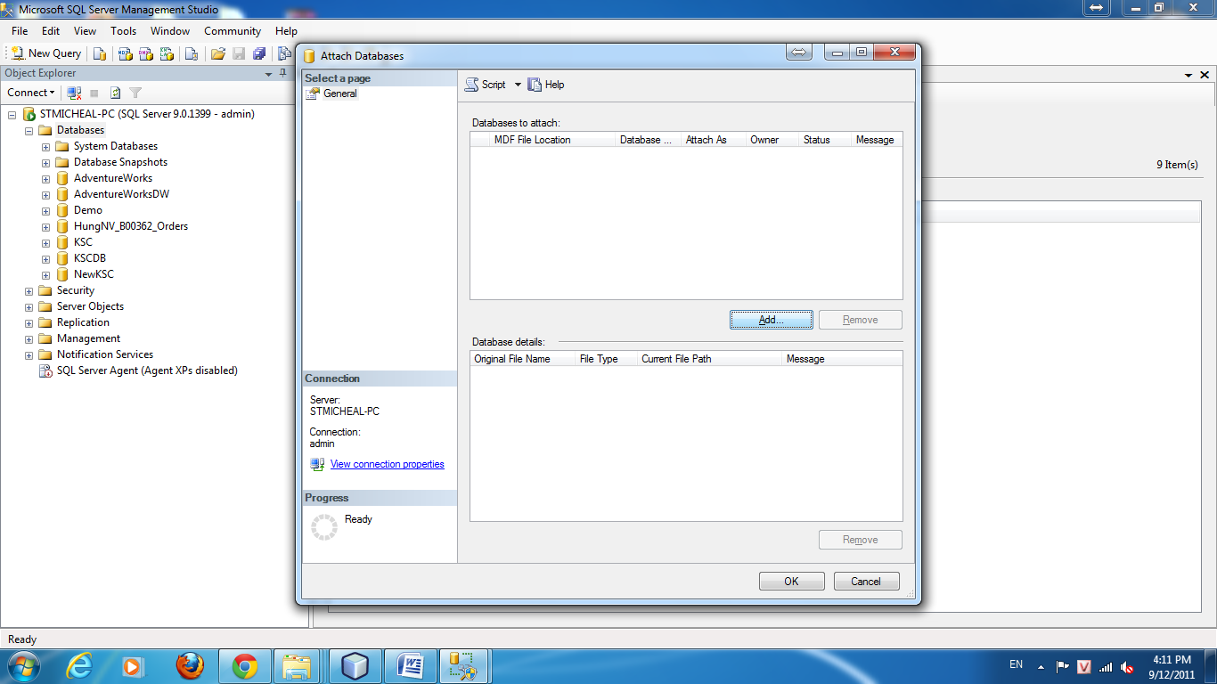
Figure 7. Choose add
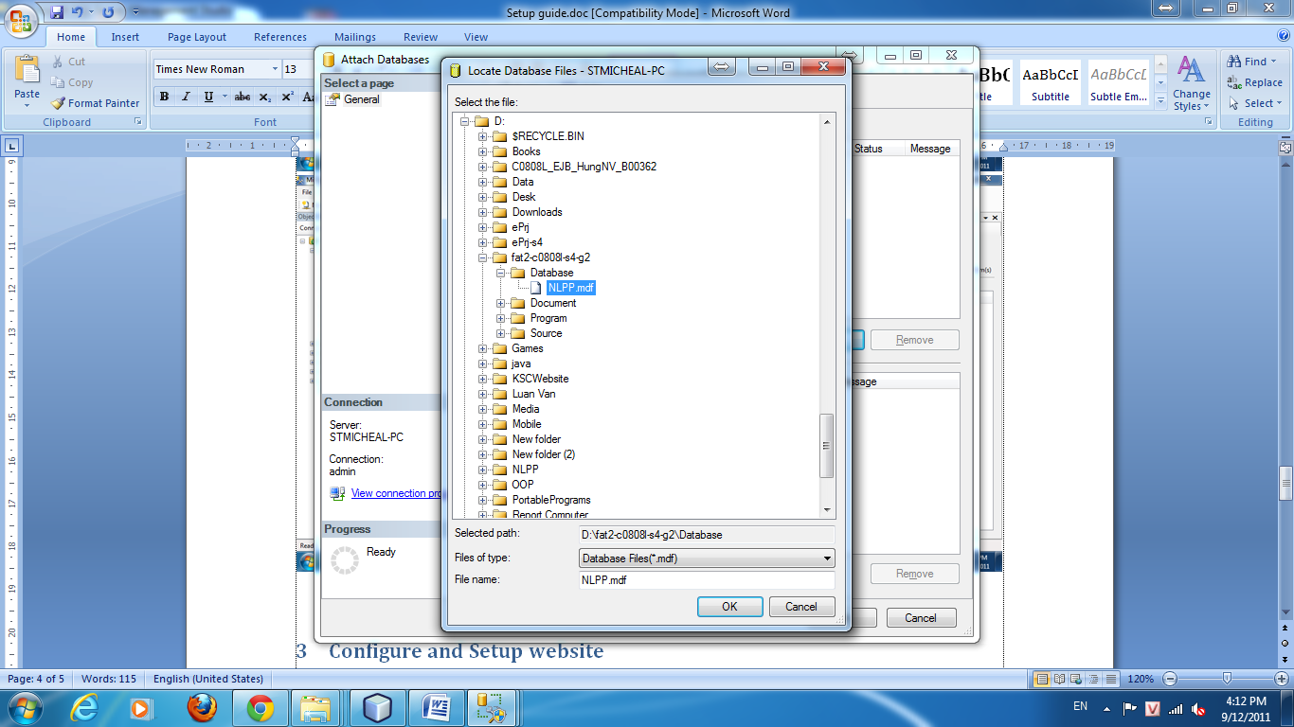
Figure 8. Choose file NLPP.mdf

Configure and Setup website
- Deploy file nlpp.war on your server.
Go to Tomcat manager page and login with tomcat account.
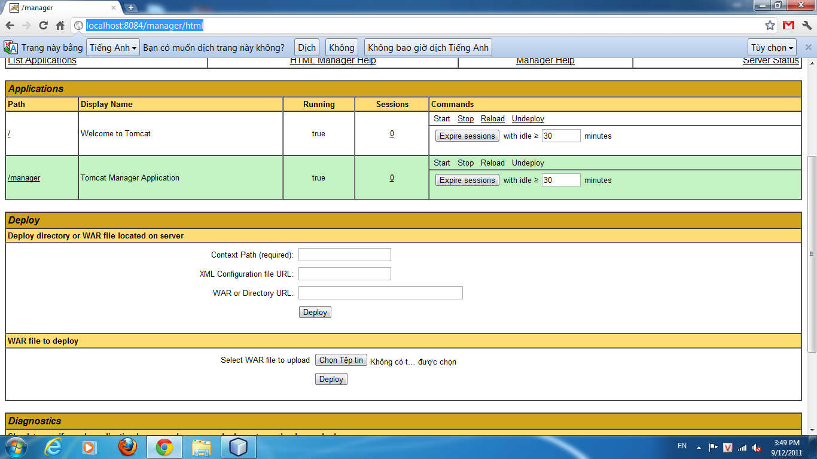
Figure 9. Go to Tomcat manager page
- Go to WAR file to deploy and select NLPP.war in Program folder.
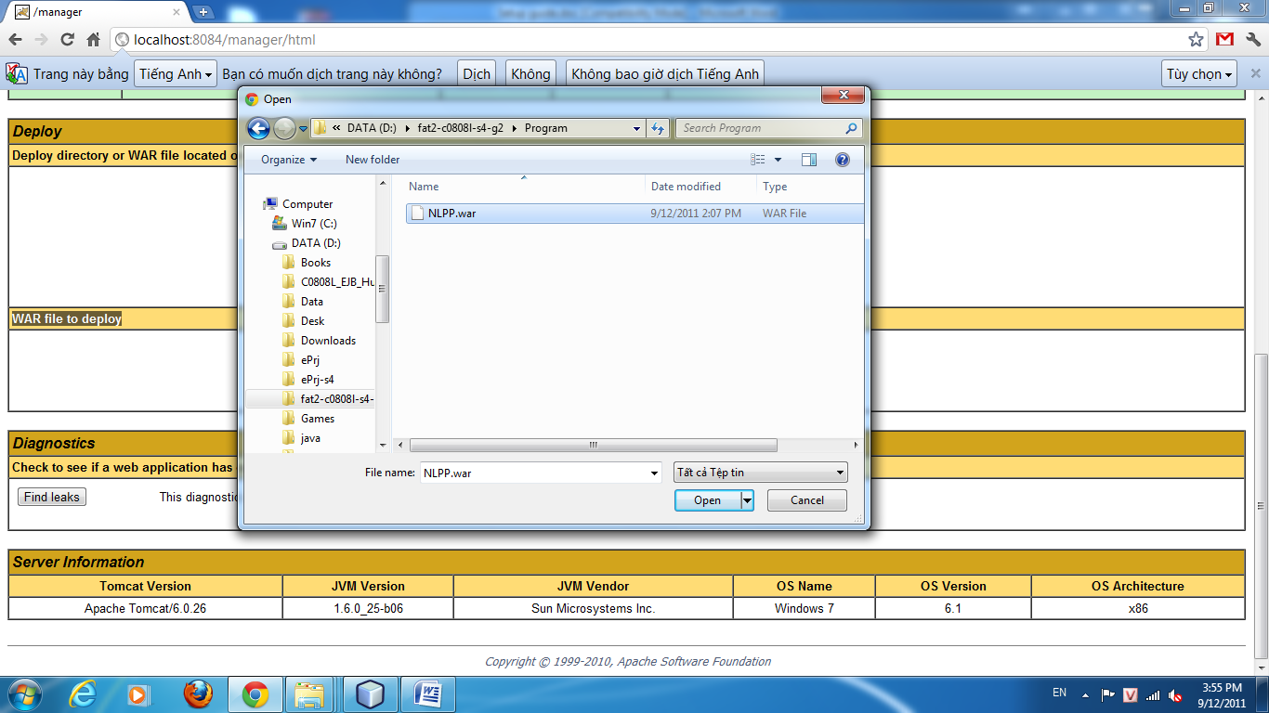
Figure 10. Select war file to deploy
- Open brower and go to: http://localhost:8084/NLPP/ to run this web.

